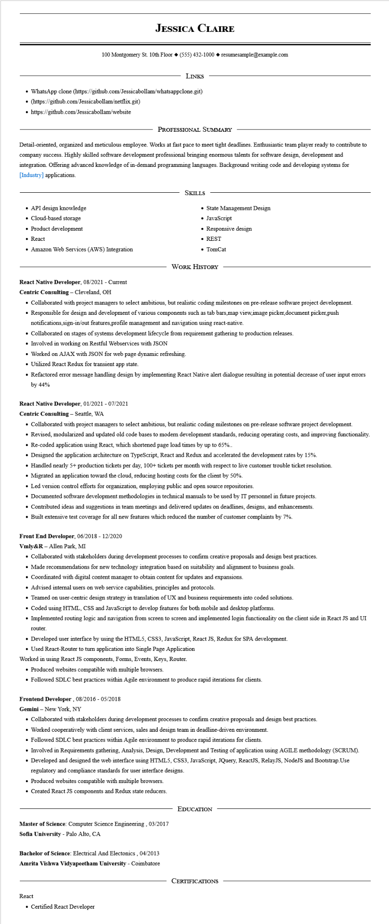
JESSICA CLAIRE
100 Montgomery St. 10th Floor (555) 432-1000 resumesample@example.com
LINKS
• WhatsApp clone (https://github.com/Jessicabollam/whatsappclone.git)
⚫ (https://github.com/Jessicabollam/netflix.git)
• https://github.com/Jessicabollam/website
PROFESSIONAL SUMMARY
Detail-oriented, organized and meticulous employee. Works at fast pace to meet tight deadlines. Enthusiastic team player ready to contribute to company success. Highly skilled software development professional bringing enormous talents for software design, development and integration. Offering advanced knowledge of in-demand programming languages. Background writing code and developing systems for [Industry] applications.
• API design knowledge
• Cloud-based storage
• Product development
• React
• Amazon Web Services (AWS) Integration
SKILLS
• State Management Design
•
JavaScript
• Responsive design
• REST
• TomCat
WORK HISTORY
React Native Developer, 08/2021 - Current
Centric Consulting - Cleveland, OH
• Collaborated with project managers to select ambitious, but realistic coding milestones on pre-release software project development.
• Responsible for design and development of various components such as tab bars,map view image picker document picker.push notifications,sign-in/out features,profile management and navigation using react-native.
• Collaborated on stages of systems development lifecycle from requirement gathering to production releases.
• Involved in working on Restful Webservices with JSON
• Worked on AJAX with JSON for web page dynamic refreshing.
• Utilized React Redux for transient app state.
• Refactored error message handling design by implementing React Native alert dialogue resulting in potential decrease of user input errors by 44%
React Native Developer, 01/2021 - 07/2021
Centric Consulting - Seattle, WA
• Collaborated with project managers to select ambitious, but realistic coding milestones on pre-release software project development.
• Revised, modularized and updated old code bases to modern development standards, reducing operating costs, and improving functionality.
• Re-coded application using React, which shortened page load times by up to 65%..
• Designed the application architecture on TypeScript, React and Redux and accelerated the development rates by 15%.
• Handled nearly 5+ production tickets per day, 100+ tickets per month with respect to live customer trouble ticket resolution.
• Migrated an application toward the cloud, reducing hosting costs for the client by 50%.
• Led version control efforts for organization, employing public and open source repositories.
• Documented software development methodologies in technical manuals to be used by IT personnel in future projects.
• Contributed ideas and suggestions in team meetings and delivered updates on deadlines, designs, and enhancements.
• Built extensive test coverage for all new features which reduced the number of customer complaints by 7%.
Front End Developer, 06/2018 - 12/2020
Vmly&R - Allen Park, MI
• Collaborated with stakeholders during development processes to confirm creative proposals and design best practices.
• Made recommendations for new technology integration based on suitability and alignment to business goals.
• Coordinated with digital content manager to obtain content for updates and expansions.
• Advised internal users on web service capabilities, principles and protocols.
• Teamed on user-centric design strategy in translation of UX and business requirements into coded solutions.
• Coded using HTML, CSS and JavaScript to develop features for both mobile and desktop platforms.
• Implemented routing logic and navigation from screen to screen and implemented login functionality on the client side in React JS and UI
router.
• Developed user interface by using the HTML5, CSS3, JavaScript, React JS, Redux for SPA development.
• Used React-Router to turn application into Single Page Application
Worked in using React JS components, Forms, Events, Keys, Router.
• Produced websites compatible with multiple browsers.
• Followed SDLC best practices within Agile environment to produce rapid iterations for clients.
Frontend Developer, 08/2016 - 05/2018
Gemini - New York, NY
• Collaborated with stakeholders during development processes to confirm creative proposals and design best practices.
• Worked cooperatively with client services, sales and design team in deadline-driven environment.
• Followed SDLC best practices within Agile environment to produce rapid iterations for clients.
• Involved in Requirements gathering, Analysis, Design, Development and Testing of application using AGILE methodology (SCRUM).
• Developed and designed the web interface using HTML5, CSS3, JavaScript, JQuery, ReactJS, RelayJS, NodeJS and Bootstrap.Use regulatory and compliance standards for user interface designs.
• Produced websites compatible with multiple browsers.
• Created React JS components and Redux state reducers.
EDUCATION
Master of Science: Computer Science Engineering, 03/2017 Sofia University - Palo Alto, CA
Bachelor of Science: Electrical And Electonics, 04/2013 Amrita Vishwa Vidyapeetham University - Coimbatore
React
• Certified React Developer
CERTIFICATIONS

